**LAMPIRAN 1**

**PERNYATAAN KEASLIAN KARYA TULIS TUGAS AKHIR**



**SISTEM INFORMASI LAZISMU KABUPATEN PEKALONGAN BERBASIS ANDROID**

**PERNYATAAN KEASLIAN KARYA TULIS TUGAS AKHIR**

Yang bertanda tangan dibawah ini :

Nama : Muhammad Fatih Mubaroq

NIM : MI.15.00298

Program Studi : Manajemen Informatika

Menyatakan dengan sesungguhnya bahwa tugas akhir,

Judul : SISTEM INFORMASI LAZISMU KABUPATEN

PEKALONGAN BERBASIS ANDROID

Adalah benar-benar hasil karya saya.

Didalam tugas akhir ini tidak terdapat gagasan orang lain yang saya ambil dengan cara menyalin atau meniru dalam bentuk rangkaian kalimat atau simbol yang saya aku seolah-olah sebagai tulisan saya sendiri tanpa melakukan pengakuan kepada penulis aslinya.

Apabila kemudian terbukti bahwa saya melakukan tindakan menyalin atau meniru tulisan orang lain seolah-olah pemikiran saya sendiri, saya bersedia menerima sanksi sesuai peraturan yang berlaku di Politeknik Muhammadiyah Pekalongan.

Pekalongan, 29 Januari 2019

Yang Memberikan Pernyataan

**Muhammad Fatih Mubaroq**

NIM : MI.15.00298

**LAMPIRAN 2**

**BUKU BIMBINGAN TUGAS AKHIR**



**SISTEM INFORMASI LAZISMU KABUPATEN PEKALONGAN BERBASIS ANDROID**

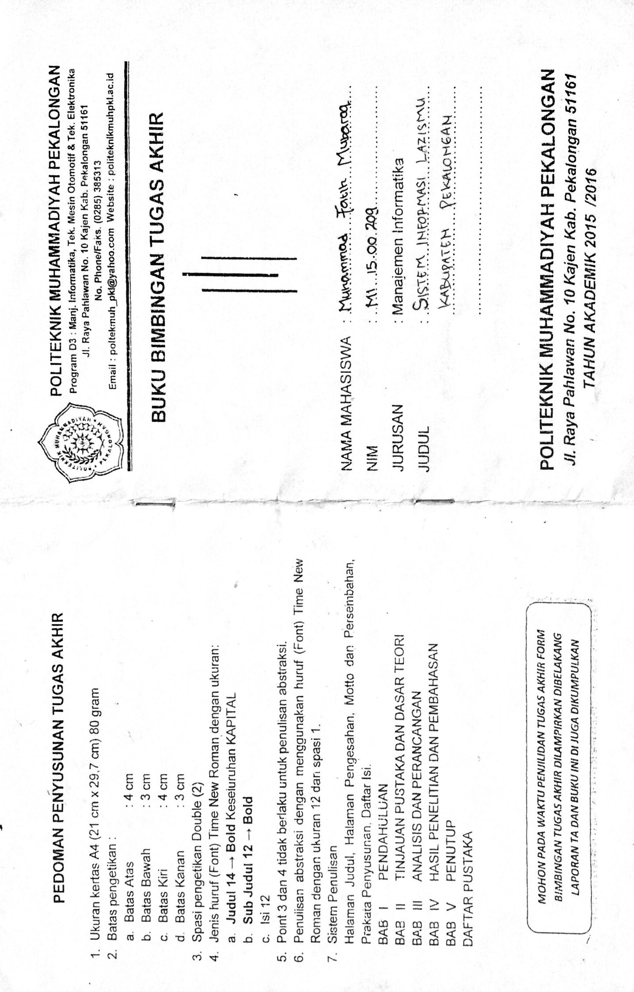

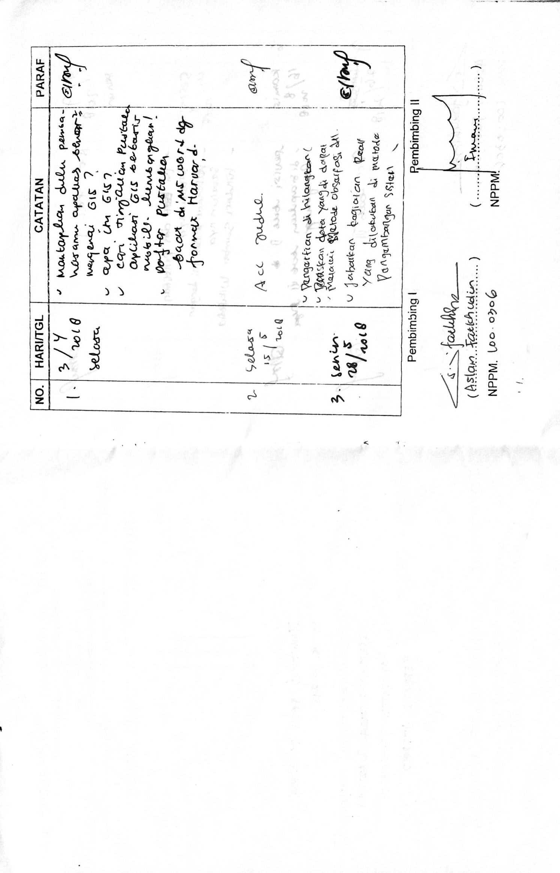

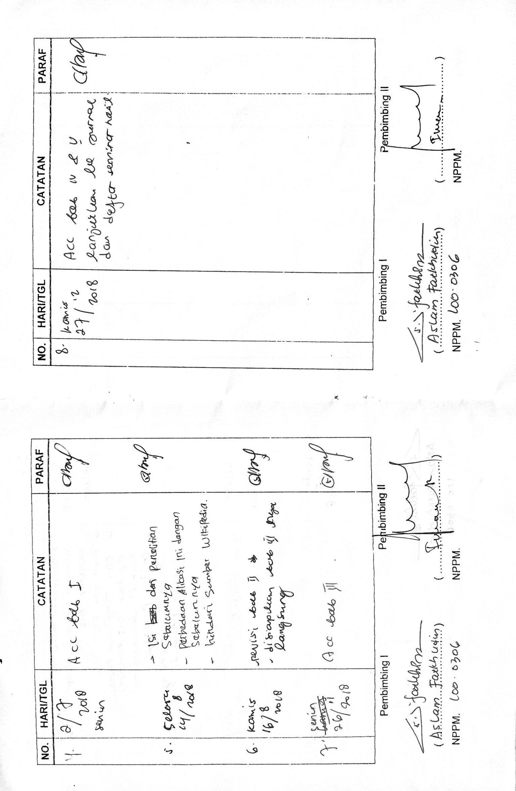

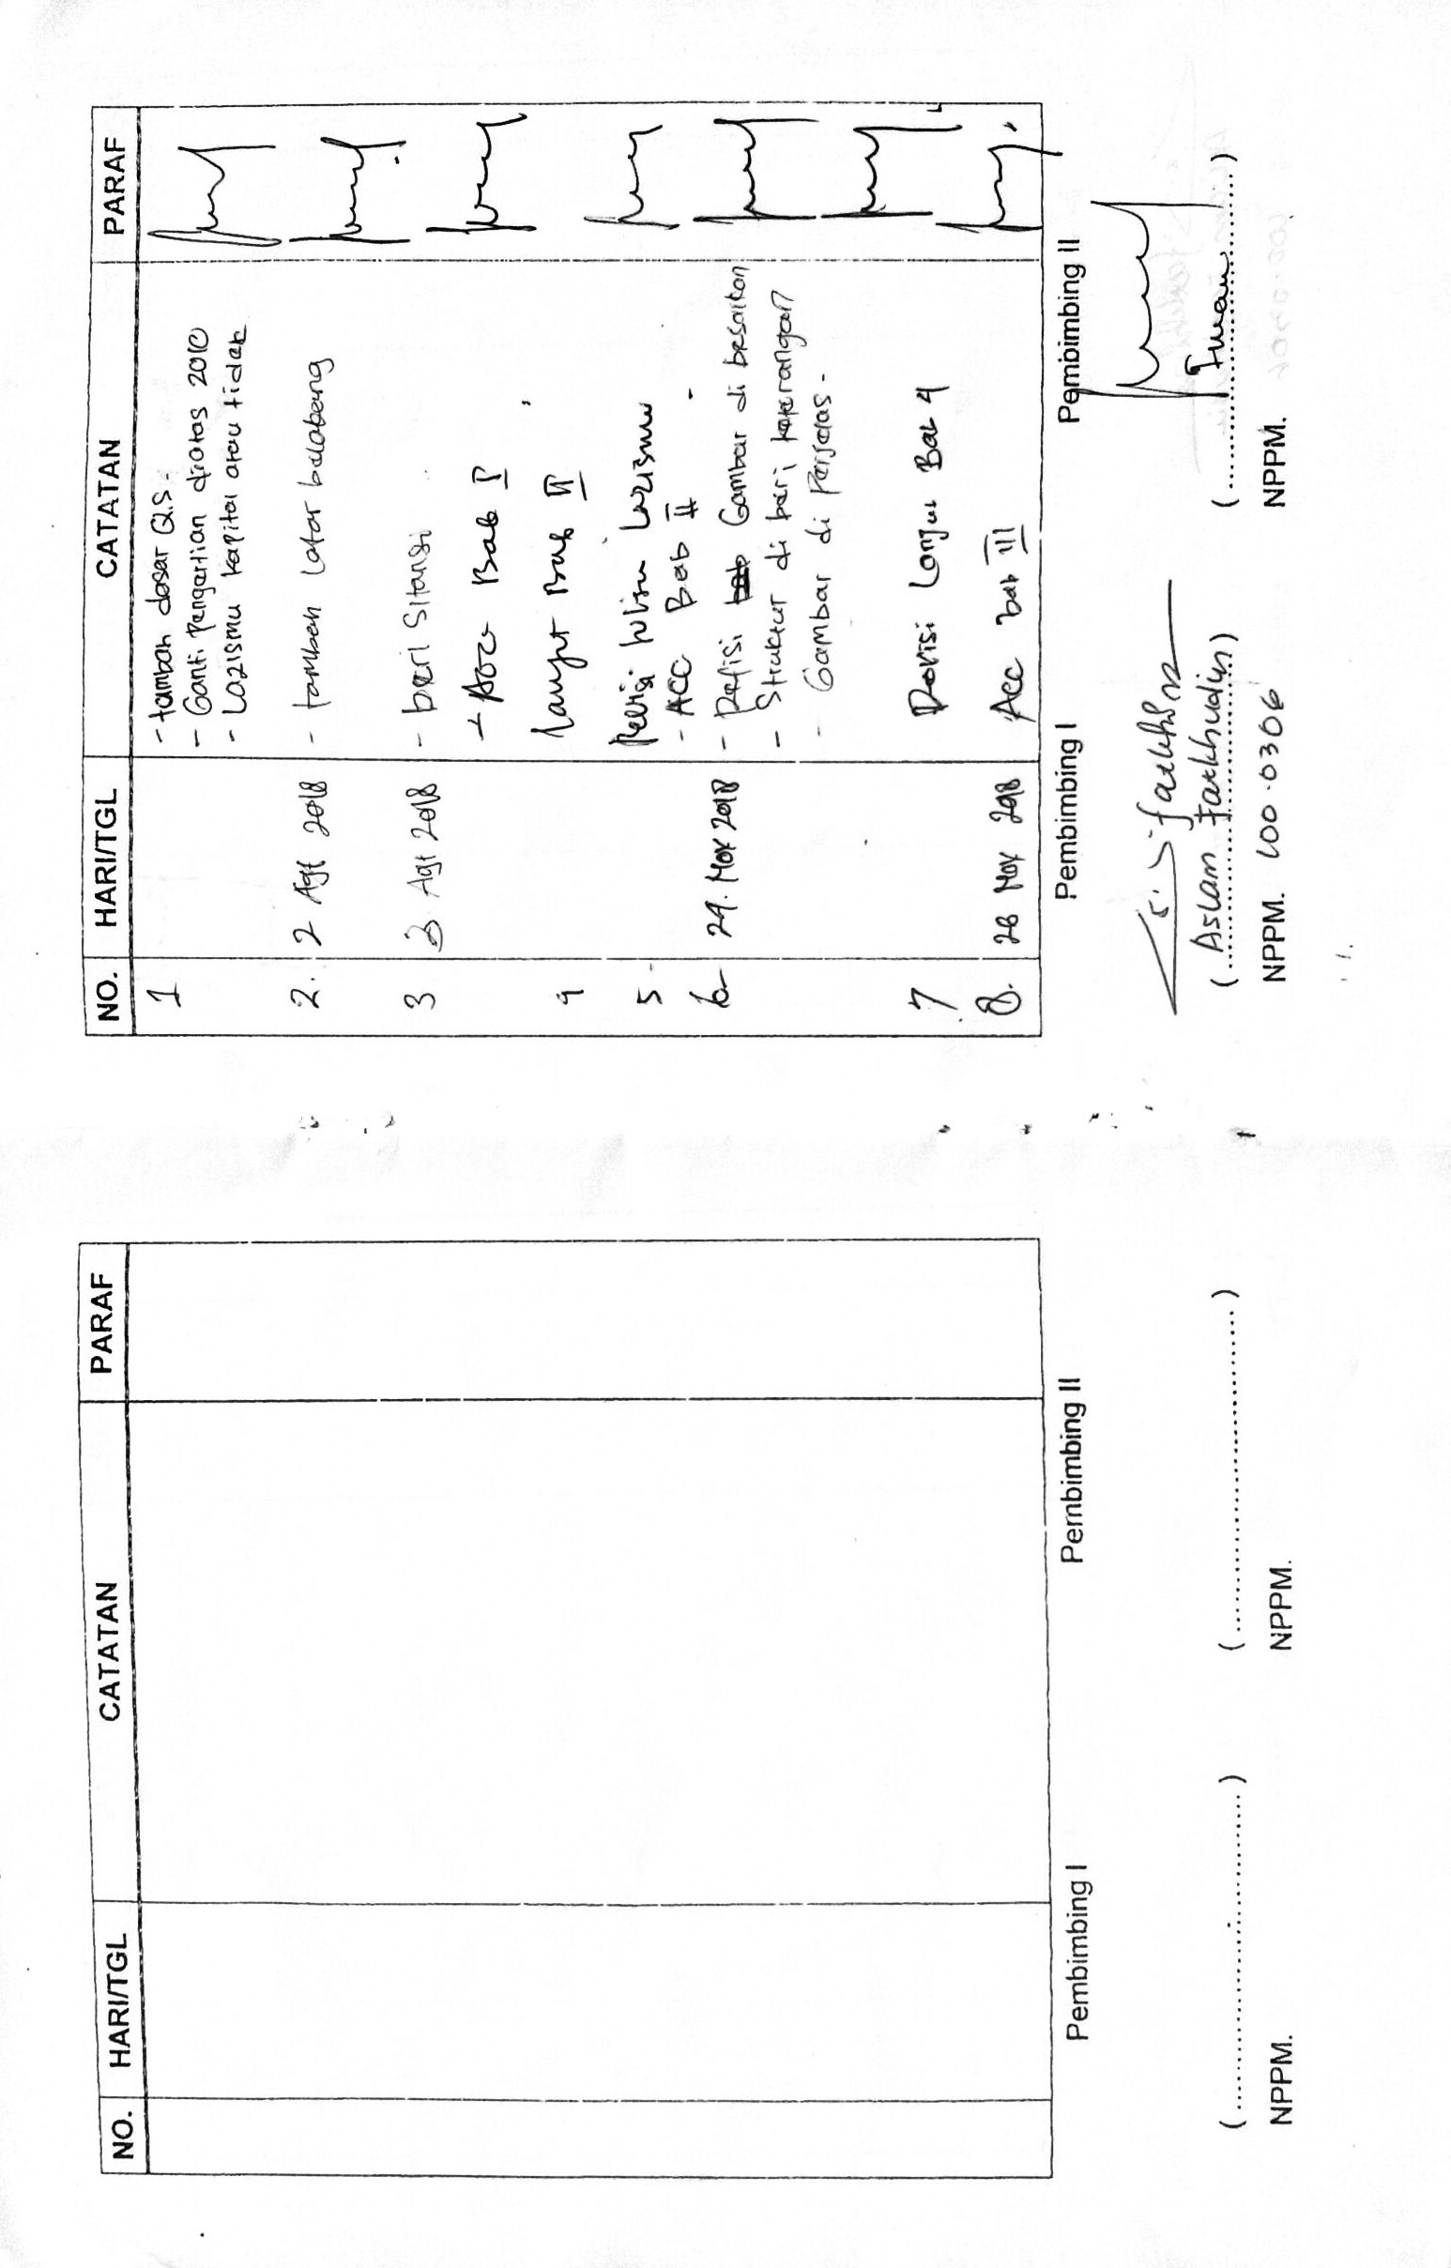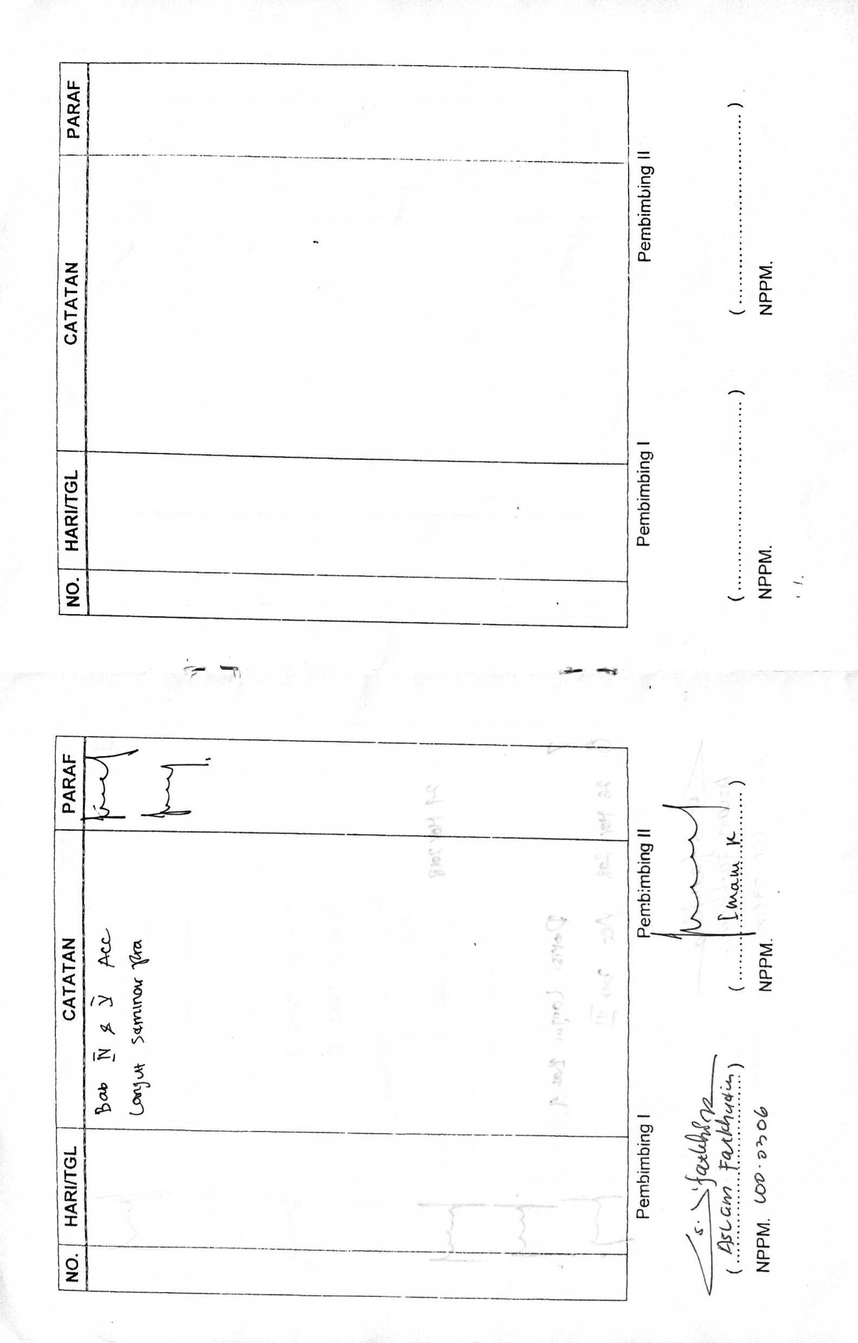

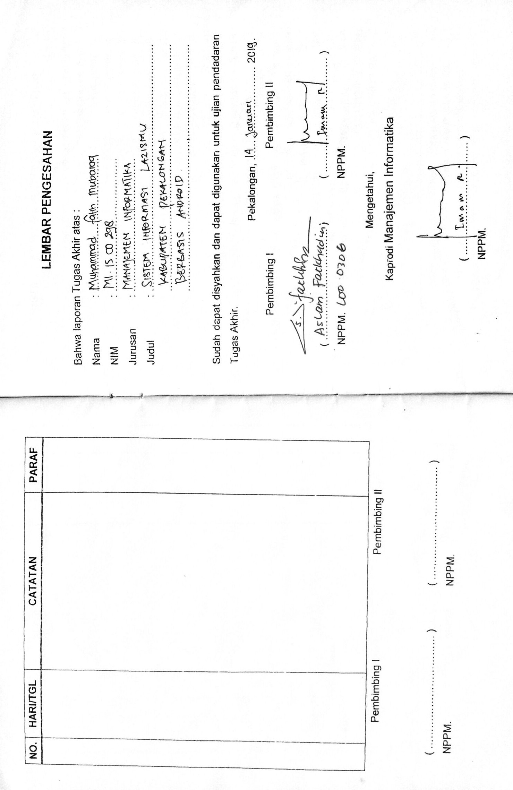**LAMPIRAN 3**

***LISTING PROGRAM***



**SISTEM INFORMASI LAZISMU KABUPATEN PEKALONGAN BERBASIS ANDROID**

***Interface* *User***

1. **AndroidManifest.xml**

<?xml version="1.0" encoding="utf-8"?>

<manifest xmlns:android="http://schemas.android.com/apk/res/android"

package="com.example.lazismu.ketek">

<uses-permission android:name="android.permission.INTERNET" />

<uses-permission android:name="android.permission.READ_EXTERNAL_STORAGE" />

<uses-permission android:name="android.permission.WRITE_EXTERNAL_STORAGE" />

<uses-permission android:name="android.permission.CAMERA" />

<application

android:allowBackup="true"

android:icon="@drawable/ic_icon"

android:label="@string/app_name"

android:largeHeap="true"

android:roundIcon="@drawable/ic_icon"

android:supportsRtl="true"

android:theme="@style/AppTheme">

<activity android:name=".sp.Splashscreen" />

<activity android:name=".Tentangkami" />

<activity android:name=".menu.zakat.item.Profesi" />

<activity android:name=".menu.Ambulan" />

<activity android:name=".menu.item.Beasiswa" />

<activity android:name=".menu.item.Beasiswa2" />

<activity android:name=".menu.zakat.Zakat" />

<activity android:name=".menu.item.Bedahrumah" />

<activity android:name=".menu.item.Umkm" />

<activity android:name=".login.Login">

<intent-filter>

<action android:name="android.intent.action.MAIN" />

<category android:name="android.intent.category.LAUNCHER" />

</intent-filter>

</activity>

<activity android:name=".login.SignUp" />

<activity android:name=".MainMenu" />

<activity android:name=".Harta" />

<activity android:name=".kalkugaji" />

<activity android:name=".menu.zakat.kalkuza.kalkuza" />

<activity android:name=".menu.Infaq" />

<activity android:name=".menu.Laporan" />

<activity android:name=".menu.Akun" />

<activity

android:name=".menu.DetailBerita"

android:label="@string/title_activity_detail_berita"

android:theme="@style/AppTheme" />

<activity

android:name=".menu.Berita"

android:theme="@style/AppTheme.NoActionBar" />

<activity android:name=".menu.zakat.item.Pertanian" />

<activity android:name=".menu.zakat.kalkuza.KalkuzaPertanian" />

<activity android:name=".menu.zakat.item.Perdagangan" />

<activity android:name=".menu.zakat.kalkuza.KalkuzaPerdagangan"></activity>

</application>

</manifest>

1. **activity_main_menu.xml**

<?xml version="1.0" encoding="utf-8"?>

<RelativeLayout xmlns:android="http://schemas.android.com/apk/res/android"

xmlns:app="http://schemas.android.com/apk/res-auto"

xmlns:tools="http://schemas.android.com/tools"

android:layout_width="match_parent"

android:layout_height="match_parent"

android:background="@drawable/ic_background"

tools:context="com.example.lazismu.ketek.MainMenu">

<ImageView

android:id="@+id/imageView2"

android:layout_width="30dp"

android:layout_height="30dp"

android:layout_marginTop="20dp"

android:layout_marginLeft="310dp"

android:src="@drawable/icon_info" />

<RelativeLayout

android:id="@+id/relativeLayout"

android:layout_width="match_parent"

android:layout_height="wrap_content"

android:layout_marginTop="62dp">

<com.daimajia.slider.library.SliderLayout

android:id="@+id/slider"

android:layout_width="fill_parent"

android:layout_height="181dp"

android:layout_alignParentStart="true"

android:layout_alignParentTop="true"

android:visibility="visible" />

</RelativeLayout>

<LinearLayout

android:id="@+id/linear1"

android:layout_below="@+id/relativeLayout"

android:layout_marginTop="20dp"

android:layout_width="match_parent"

android:layout_height="wrap_content"

android:layout_marginRight="190dp"

android:layout_marginLeft="40dp"

android:orientation="vertical">

<ImageView

android:id="@+id/imageView5"

android:layout_width="60dp"

android:layout_height="60dp"

android:layout_gravity="center"

android:src="@drawable/ic_zakat1" />

<TextView

android:id="@+id/textView3"

android:layout_width="wrap_content"

android:layout_height="wrap_content"

android:text=" ZAKAT"

android:layout_gravity="center"

android:textStyle="bold" />

<ImageView

android:id="@+id/imageView6"

android:layout_width="60dp"

android:layout_height="60dp"

android:layout_marginTop="19dp"

android:layout_gravity="center"

android:src="@drawable/ic_infaq" />

<TextView

android:id="@+id/textView4"

android:layout_width="wrap_content"

android:layout_height="wrap_content"

android:layout_gravity="center"

android:text="INFAQ, SEDEKAH"

android:textStyle="bold" />

</LinearLayout>

<LinearLayout

android:layout_below="@+id/relativeLayout"

android:layout_width="match_parent"

android:layout_height="wrap_content"

android:orientation="vertical"

android:layout_marginRight="40dp">

<ImageView

android:id="@+id/imageView4"

android:layout_width="60dp"

android:layout_height="60dp"

android:layout_gravity="center"

android:src="@drawable/ic_ambulance" />

<TextView

android:id="@+id/textView2"

android:layout_width="wrap_content"

android:layout_height="wrap_content"

android:text="AMBULAN GRATIS"

android:layout_gravity="center"

android:textStyle="bold" />

<ImageView

android:id="@+id/imageView7"

android:layout_width="60dp"

android:layout_height="60dp"

android:layout_gravity="center"

android:src="@drawable/ic_laporan" />

<TextView

android:layout_width="wrap_content"

android:layout_height="wrap_content"

android:layout_gravity="center"

android:text="LAPORAN \nTRANSAKSI"

android:textAlignment="center"

android:textStyle="bold" />

</LinearLayout>

<LinearLayout

android:layout_below="@+id/linear1"

android:layout_marginTop="15dp"

android:layout_width="match_parent"

android:layout_height="wrap_content"

android:orientation="vertical">

<ImageView

android:id="@+id/imageView9"

android:layout_width="60dp"

android:layout_height="60dp"

android:layout_marginTop="19dp"

android:layout_gravity="center"

android:src="@drawable/ic_akun" />

<TextView

android:id="@+id/textView5"

android:layout_width="wrap_content"

android:layout_height="wrap_content"

android:layout_gravity="center"

android:text="AKUN"/>

</LinearLayout>

</RelativeLayout>

1. **MainMenu.java**

package com.example.lazismu.ketek;

import android.Manifest;

import android.content.Intent;

import android.content.pm.PackageManager;

import android.os.Bundle;

……….

public class MainMenu extends AppCompatActivity implements BaseSliderView.OnSliderClickListener,

ViewPagerEx.OnPageChangeListener, View.OnClickListener {

SliderLayout sliderLayout;

HashMap<String, String> HashMapForURL;

HashMap<String, Integer> HashMapForLocalRes;

private ImageView btnZakat, btnAmbulance, btninfaq, btnlaporan, btnakun, btnInfo;

SharedLogin sharedLogin;

@Override

protected void onCreate(Bundle savedInstanceState) {

super.onCreate(savedInstanceState);

setContentView(R.layout.activity_main_menu);

sharedLogin = new SharedLogin(this);

if (sharedLogin.getSharedSudahLogin()) {

if (!sharedLogin.getSharedSudahLogin2()) {

startActivity(new Intent(MainMenu.this, Login.class)

.addFlags(Intent.FLAG_ACTIVITY_CLEAR_TOP | Intent.FLAG_ACTIVITY_NEW_TASK));

finish();

}

}

konek();

sliderLayout = (SliderLayout) findViewById(R.id.slider);

getBerita();

sliderLayout.setPresetTransformer(SliderLayout.Transformer.DepthPage);

sliderLayout.setPresetIndicator(SliderLayout.PresetIndicators.Center_Bottom);

sliderLayout.setCustomAnimation(new DescriptionAnimation());

sliderLayout.setDuration(3000);

sliderLayout.addOnPageChangeListener(MainMenu.this);

if (ContextCompat.checkSelfPermission(this, Manifest.permission.CAMERA) != PackageManager.PERMISSION_GRANTED) {

ActivityCompat.requestPermissions(this, new String[] { Manifest.permission.READ_EXTERNAL_STORAGE, Manifest.permission.CAMERA, Manifest.permission.WRITE_EXTERNAL_STORAGE }, 0);

}

}

@Override

public void onRequestPermissionsResult(int requestCode, String[] permissions, int[] grantResults) {

if (requestCode == 0) {

if (grantResults.length > 0 && grantResults[0] == PackageManager.PERMISSION_GRANTED

&& grantResults[0] == PackageManager.PERMISSION_GRANTED) {

}

}

}

@Override

protected void onStop() {

sliderLayout.stopAutoCycle();

super.onStop();

}

@Override

public void onSliderClick(BaseSliderView slider) {

//Toast.makeText(this, slider.getBundle().get("extra") + "", Toast.LENGTH_SHORT).show();

Buka.buka(MainMenu.this, Berita.class);

}

@Override

public void onPageScrolled(int position, float positionOffset, int positionOffsetPixels) {

}

@Override

public void onPageSelected(int position) {

Log.d("Slider Demo", "Page Changed: " + position);

}

@Override

public void onPageScrollStateChanged(int state) {

}

public void AddImagesUrlOnline() {

HashMapForURL = new HashMap<String, String>();

HashMapForURL.put("CupCake", "http://d1nnx3nhddxmeh.cloudfront.net/wp-content/uploads/2017/01/10154602/Tea-Leoni-.png");

HashMapForURL.put("Donut", "http://androidblog.esy.es/images/donut-2.png");

HashMapForURL.put("Eclair", "http://androidblog.esy.es/images/eclair-3.png");

HashMapForURL.put("Froyo", "http://androidblog.esy.es/images/froyo-4.png");

HashMapForURL.put("GingerBread", "http://androidblog.esy.es/images/gingerbread-5.png");

}

@Override

public void onClick(View v) {

switch (v.getId()) {

case R.id.imageView5:

//TODO BUKA HALAMAN

Buka.buka(MainMenu.this, Zakat.class);

break;

case R.id.imageView4:

Buka.buka(MainMenu.this, Ambulan.class);

break;

case R.id.imageView6:

Buka.buka(MainMenu.this, Infaq.class);

break;

case R.id.imageView7:

Buka.buka(MainMenu.this, Laporan.class);

break;

case R.id.imageView9:

Buka.buka(MainMenu.this, Akun.class);

break;

case R.id.imageView2:

Buka.buka(MainMenu.this, Tentangkami.class);

break;

}

}

private void konek() {

btnZakat = findViewById(R.id.imageView5);

btnAmbulance = findViewById(R.id.imageView4);

btninfaq = findViewById(R.id.imageView6);

btnlaporan = findViewById(R.id.imageView7);

btnakun = findViewById(R.id.imageView9);

btnInfo = findViewById(R.id.imageView2);

btnZakat.setOnClickListener(this);

btnAmbulance.setOnClickListener(this);

btninfaq.setOnClickListener(this);

btnlaporan.setOnClickListener(this);

btnakun.setOnClickListener(this);

btnInfo.setOnClickListener(this);

}

private void getBerita() {

ApiService apiService = RetroClient.getApiService();

Call<ResponseBerita> call = apiService.getBerita();

call.enqueue(new Callback<ResponseBerita>() {

@Override

public void onResponse(Call<ResponseBerita> call, Response<ResponseBerita> response) {

//Log.e("Tag", "Hasil List :" + new Gson().toJson(hasilPesan));

if (response.body().getSukses().equalsIgnoreCase("true")) {

try {

HashMapForURL = new HashMap<String, String>();

for (int i = 0; i < response.body().getBerita().size(); i++) {

HashMapForURL.put(response.body().getBerita().get(i).getJudul(),

URL_IMAGE + response.body().getBerita().get(i).getGambar());

}

for (String name : HashMapForURL.keySet()) {

TextSliderView textSliderView = new TextSliderView(MainMenu.this);

textSliderView

.description(name)

.image(HashMapForURL.get(name))

.setScaleType(BaseSliderView.ScaleType.Fit)

.setOnSliderClickListener(MainMenu.this);

textSliderView.bundle(new Bundle());

textSliderView.getBundle()

.putString("extra", name);

sliderLayout.addSlider(textSliderView);

}

} catch (Exception e) {

Toast.makeText(MainMenu.this, e.getMessage(), Toast.LENGTH_SHORT).show();

}

} else {

Log.e("Tag", "Gagal req data ");

}

}

@Override

public void onFailure(Call<ResponseBerita> call, Throwable t) {

Toast.makeText(MainMenu.this, t.getMessage(), Toast.LENGTH_SHORT).show();

}

});

}

}

1. **Harta.java**

package com.example.lazismu.ketek;

import android.app.AlertDialog;

import android.app.Dialog;

import android.content.Context;

import android.content.DialogInterface;

import android.content.Intent;

………………………………

public class Harta extends AppCompatActivity {

private MediaPlayer mp;

private Button lanjut;

private ImageView btnPlay;

private ImageView imageview;

private static final String IMAGE_DIRECTORY = "/Lazismu";

private int GALLERY = 1, CAMERA = 2;

TextView kalkulator;

private EditText edmas, edpertanian, edpertanian1, edbarangTemuan, edperdagangan, edternak, edgalian, edhasil1;

@Override

protected void onCreate(Bundle savedInstanceState) {

super.onCreate(savedInstanceState);

setContentView(R.layout.activity_harta);

mp = new MediaPlayer();

btnPlay = (ImageView) findViewById(R.id.btnPLAY);

btnPlay.setOnClickListener(new View.OnClickListener() {

@Override

public void onClick(View v) {

play();

btnPlay.setEnabled(false);

}

});

lanjut = findViewById(R.id.btnlanjut);

lanjut.setOnClickListener(new View.OnClickListener() {

@Override

public void onClick(View v) {

final Dialog unggah = new Dialog(Harta.this, R.style.NewDialog);

unggah.setContentView(R.layout.upload);

unggah.setCancelable(true);

unggah.setCanceledOnTouchOutside(true);

imageview = unggah.findViewById(R.id.iv);

imageview.setOnClickListener(new View.OnClickListener() {

@Override

public void onClick(View v) {

showPictureDialog();

}

});

unggah.show();

if (Build.VERSION.SDK_INT >= Build.VERSION_CODES.KITKAT) {

Objects.requireNonNull(unggah.getWindow()).setLayout(650, 1000);

}

}

});

kalkulator = findViewById(R.id.txtkal);

edmas = (EditText) findViewById(R.id.edmas);

edpertanian = (EditText) findViewById(R.id.edpertanian);

edpertanian1 = (EditText) findViewById(R.id.edpertanian1);

edbarangTemuan = (EditText) findViewById(R.id.edtemuan);

edperdagangan = (EditText) findViewById(R.id.edperdagangan);

edternak = (EditText) findViewById(R.id.edternak);

edgalian = (EditText) findViewById(R.id.edgalian);

edhasil1 = (EditText) findViewById(R.id.edhasil1);

edmas.addTextChangedListener(EditAngka.onTextChangedListener(edmas));

Bundle intent = getIntent().getExtras();

if (intent != null){

double nilai = intent.getDouble("hasil");

Log.v("Nilai", ""+nilai);

Locale localeID = new Locale("in", "ID");

NumberFormat formatRupiah = NumberFormat.getCurrencyInstance(localeID);

edhasil1.setText(formatRupiah.format(nilai));

}

kalkulator.setOnClickListener(new View.OnClickListener() {

@Override

public void onClick(View v) {

startActivity(new Intent(Harta.this, kalkugaji.class));

}

});

Spinner mySpinner = (Spinner) findViewById(R.id.spinner1);

ArrayAdapter<String> myAdapter = new ArrayAdapter<String>(Harta.this,

android.R.layout.simple_list_item_1, getResources().getStringArray(R.array.names1));

myAdapter.setDropDownViewResource(android.R.layout.simple_spinner_dropdown_item);

mySpinner.setAdapter(myAdapter);

}

private void showPictureDialog() {

AlertDialog.Builder pictureDialog = new AlertDialog.Builder(Harta.this, R.style.NewDialog);

pictureDialog.setTitle("Pilih Tindakan");

String[] pictureDialogItems = {

"Pilih dari Galeri",

"Ambil Foto dari Kamera"};

pictureDialog.setItems(pictureDialogItems,

new DialogInterface.OnClickListener() {

@Override

public void onClick(DialogInterface dialog, int which) {

switch (which) {

case 0:

choosePhotoFromGallary();

break;

case 1:

takePhotoFromCamera();

break;

}

}

});

pictureDialog.show();

}

public void choosePhotoFromGallary() {

Intent galleryIntent = new Intent(Intent.ACTION_PICK,

android.provider.MediaStore.Images.Media.EXTERNAL_CONTENT_URI);

startActivityForResult(galleryIntent, GALLERY);

}

private void takePhotoFromCamera() {

Intent intent = new Intent(android.provider.MediaStore.ACTION_IMAGE_CAPTURE);

startActivityForResult(intent, CAMERA);

}

@Override

public void onActivityResult(int requestCode, int resultCode, Intent data) {

super.onActivityResult(requestCode, resultCode, data);

if (resultCode == this.RESULT_CANCELED) {

return;

}

if (requestCode == GALLERY) {

if (data != null) {

Uri contentURI = data.getData();

try {

Bitmap bitmap = MediaStore.Images.Media.getBitmap(this.getContentResolver(), contentURI);

String path = saveImage(bitmap);

Toast.makeText(Harta.this, "Image Saved!", Toast.LENGTH_SHORT).show();

imageview.setImageBitmap(bitmap);

} catch (IOException e) {

e.printStackTrace();

Toast.makeText(Harta.this, "Failed!", Toast.LENGTH_SHORT).show();

}

}

} else if (requestCode == CAMERA) {

Bitmap thumbnail = (Bitmap) data.getExtras().get("data");

imageview.setImageBitmap(thumbnail);

saveImage(thumbnail);

Toast.makeText(Harta.this, "Image Saved!", Toast.LENGTH_SHORT).show();

}

}

public String saveImage(Bitmap myBitmap) {

ByteArrayOutputStream bytes = new ByteArrayOutputStream();

myBitmap.compress(Bitmap.CompressFormat.JPEG, 90, bytes);

File wallpaperDirectory = new File(

Environment.getExternalStorageDirectory() + IMAGE_DIRECTORY);

if (!wallpaperDirectory.exists()) {

wallpaperDirectory.mkdirs();

}

try {

File f = new File(wallpaperDirectory, Calendar.getInstance()

.getTimeInMillis() + ".jpg");

f.createNewFile();

FileOutputStream fo = new FileOutputStream(f);

fo.write(bytes.toByteArray());

MediaScannerConnection.scanFile(this,

new String[]{f.getPath()},

new String[]{"image/jpeg"}, null);

fo.close();

Log.d("TAG", "File Saved::--->" + f.getAbsolutePath());

return f.getAbsolutePath();

} catch (IOException e1) {

e1.printStackTrace();

}

return "";

}

private void play() {

mp = MediaPlayer.create(this, R.raw.niatzakat);

try {

mp.prepare();

} catch (IllegalStateException e) {

e.printStackTrace();

} catch (IOException e) {

e.printStackTrace();

}

mp.start();

mp.setOnCompletionListener(new MediaPlayer.OnCompletionListener() {

@Override

public void onCompletion(MediaPlayer mp) {

btnPlay.setEnabled(true);

}

});

}

}

1. **Ambulan.java**

package com.example.lazismu.ketek.menu;

import android.app.AlertDialog;

import android.app.DatePickerDialog;

import android.app.ProgressDialog;

import android.content.DialogInterface;

import android.os.Bundle;

import android.support.v7.app.AppCompatActivity;

………………………….

public class Ambulan extends AppCompatActivity {

@BindView(R.id.edt_id)

EditText edtId;

@BindView(R.id.edt_sopir)

EditText edtSopir;

@BindView(R.id.txt_pinjam)

TextView txtPinjam;

@BindView(R.id.txt_kembali)

TextView txtKembali;

@BindView(R.id.edt_tujuan)

EditText edtTujuan;

@BindView(R.id.btnkonfirm)

Button btnkonfirm;

SharedLogin sharedLogin;

ProgressDialog progressDialog;

@BindView(R.id.sp_mobil)

Spinner spMobil;

@BindView(R.id.txt_kosong)

TextView txtKosong;

@BindView(R.id.sp_sim)

Spinner spSim;

@BindView(R.id.txt_sim)

TextView txtSim;

@BindView(R.id.txt_mobil)

TextView txtMobil;

private Calendar myCalendar;

AmbulanItem data;

CustomAdapter customAdapter;

List<DataAmbulan2Item> hasilPesan;

@Override

protected void onCreate(Bundle savedInstanceState) {

super.onCreate(savedInstanceState);

setContentView(R.layout.coba);

ButterKnife.bind(this);

sharedLogin = new SharedLogin(this);

progressDialog = new ProgressDialog(this);

progressDialog.setIndeterminate(true);

progressDialog.setMessage("Tunggu Sebentar...");

myCalendar = Calendar.getInstance();

getDataAmbula();

edtId.setText(sharedLogin.getSharedString(SharedLogin.SP_NAMA));

final ArrayAdapter<CharSequence> adapterStatus = ArrayAdapter.createFromResource(this, R.array.sim,

R.layout.support_simple_spinner_dropdown_item);

spSim.setAdapter(adapterStatus);

spSim.setOnItemSelectedListener(new AdapterView.OnItemSelectedListener() {

@Override

public void onItemSelected(AdapterView<?> parent, View view, int position, long id) {

txtSim.setText(adapterStatus.getItem(position).toString());

if (adapterStatus.getItem(position).toString().equalsIgnoreCase("Ya")){

btnkonfirm.setEnabled(true);

}

}

@Override

public void onNothingSelected(AdapterView<?> parent) {

}

});

spMobil.setOnItemSelectedListener(new AdapterView.OnItemSelectedListener() {

@Override

public void onItemSelected(AdapterView<?> parent, View view, int position, long id) {

//Toast.makeText(getActivity(), hasilPesan.get(position).getJudul(), Toast.LENGTH_SHORT).show();

try {

txtMobil.setText(hasilPesan.get(position).getIdAmbulan());

} catch (Exception e) {

}

}

@Override

public void onNothingSelected(AdapterView<?> parent) {

}

});

data = getIntent().getParcelableExtra(KEY_DATA);

if (data != null) {

edtSopir.setText(data.getNamaDriver());

txtPinjam.setText(ubahTanggal2(data.getTglPinjam()));

txtKembali.setText(ubahTanggal2(data.getTglKembali()));

edtTujuan.setText(data.getTujuan());

int posisi = adapterStatus.getPosition(data.getSim());

spSim.setSelection(posisi);

txtSim.setText(data.getSim());

} else {

txtPinjam.setText(ubahTanggal2(tglHariIni()));

txtKembali.setText(ubahTanggal2(tglHariIni()));

}

}

@OnClick({R.id.txt_pinjam, R.id.txt_kembali, R.id.btnkonfirm})

public void onViewClicked(View view) {

switch (view.getId()) {

case R.id.txt_pinjam:

new DatePickerDialog(Ambulan.this, new DatePickerDialog.OnDateSetListener() {

@Override

public void onDateSet(DatePicker view, int year, int month, int dayOfMonth) {

myCalendar.set(Calendar.YEAR, year);

myCalendar.set(Calendar.MONTH, month);

myCalendar.set(Calendar.DAY_OF_MONTH, dayOfMonth);

String formatTanggal = "yyyy-MM-dd";

SimpleDateFormat sdf = new SimpleDateFormat(formatTanggal);

txtPinjam.setText(ubahTanggal2(sdf.format(myCalendar.getTime())));

}

},

myCalendar.get(Calendar.YEAR), myCalendar.get(Calendar.MONTH),

myCalendar.get(Calendar.DAY_OF_MONTH)).show();

break;

case R.id.txt_kembali:

new DatePickerDialog(Ambulan.this, new DatePickerDialog.OnDateSetListener() {

@Override

public void onDateSet(DatePicker view, int year, int month, int dayOfMonth) {

myCalendar.set(Calendar.YEAR, year);

myCalendar.set(Calendar.MONTH, month);

myCalendar.set(Calendar.DAY_OF_MONTH, dayOfMonth);

String formatTanggal = "yyyy-MM-dd";

SimpleDateFormat sdf = new SimpleDateFormat(formatTanggal);

txtKembali.setText(ubahTanggal2(sdf.format(myCalendar.getTime())));

}

},

myCalendar.get(Calendar.YEAR), myCalendar.get(Calendar.MONTH),

myCalendar.get(Calendar.DAY_OF_MONTH)).show();

break;

case R.id.btnkonfirm:

if (cekEditText(edtId)) {

setErrorEditText(edtId, "ID Kosong");

} else if (cekEditText(edtSopir)) {

setErrorEditText(edtSopir, "Nama Sopir Kosong");

} else if (cekEditText(edtTujuan)) {

setErrorEditText(edtTujuan, "Tujuan Kosong");

} else if (cekTextView(txtPinjam)) {

Toast.makeText(this, "Tanggal Pinjam Kosong", Toast.LENGTH_SHORT).show();

} else if (cekTextView(txtKembali)) {

Toast.makeText(this, "Tanggal Pinjam Kosong", Toast.LENGTH_SHORT).show();

} else {

if (data == null) {

if (cariTigaTanggal(getTextView(txtPinjam), getTextView(txtKembali))){

simpan(getTextEditText(edtId), getTextEditText(edtSopir), ubahTanggal3(getTextView(txtPinjam)),

ubahTanggal3(getTextView(txtKembali)), getTextEditText(edtTujuan), getTextView(txtMobil),

getTextView(txtSim));

}else {

Toast.makeText(Ambulan.this, "Tanggal pinjam tidak boleh lebih dari tiga hari", Toast.LENGTH_SHORT).show();

}

} else {

updateWithField(data.getIdAmbulan(), getTextEditText(edtSopir), ubahTanggal3(getTextView(txtPinjam)),

ubahTanggal3(getTextView(txtKembali)), getTextEditText(edtTujuan), data.getPesan(), data.getStatus(),

getTextView(txtMobil), getTextView(txtSim));

}

}

break;

}

}

private void simpan(String id, String nama, String tglPinjam, String tglKembali, String tujuan, String idAmbulan, String sim) {

progressDialog.show();

ApiService service = RetroClient.getApiService();

Call<ResponseInsert> call = service.insertAmbulan(id, nama, tglPinjam, tglKembali, tujuan, sim, idAmbulan);

call.enqueue(new Callback<ResponseInsert>() {

@Override

public void onResponse(Call<ResponseInsert> call, Response<ResponseInsert> response) {

progressDialog.dismiss();

if (response.body().getCode() == 200) {

Toast.makeText(getApplicationContext(), response.body().getMessage(), Toast.LENGTH_SHORT).show();

kosongkan();

} else {

Toast.makeText(getApplicationContext(), response.body().getMessage(), Toast.LENGTH_SHORT).show();

}

}

@Override

public void onFailure(Call<ResponseInsert> call, Throwable t) {

Toast.makeText(getApplicationContext(), "" + t.getMessage(), Toast.LENGTH_SHORT).show();

progressDialog.dismiss();

}

});

}

private void kosongkan() {

FunctionError.kosongkan(edtTujuan);

FunctionError.kosongkan(edtSopir);

}

public void updateWithField(String id, String nama, String tglPinjam, String tglKembali,

String tujuan, String pesan, String status, String idAmbulan, String sim) {

ApiService service = RetroClient.getApiService();

Call<ResponseInsert> call = service.updateAmbulan(Integer.parseInt(id), nama, tglPinjam, tglKembali, tujuan, pesan,

status, idAmbulan, sim);

call.enqueue(new Callback<ResponseInsert>() {

@Override

public void onResponse(Call<ResponseInsert> call, Response<ResponseInsert> response) {

if (response.body().getCode() == 200) {

Toast.makeText(Ambulan.this, response.body().getMessage(), Toast.LENGTH_SHORT).show();

Ambulan.this.startActivity(new Intent(Ambulan.this, Laporan.class)

.addFlags(Intent.FLAG_ACTIVITY_CLEAR_TOP | Intent.FLAG_ACTIVITY_NEW_TASK));

//hancurkan activity

} else {

Toast.makeText(Ambulan.this, response.body().getMessage(), Toast.LENGTH_SHORT).show();

}

}

@Override

public void onFailure(Call<ResponseInsert> call, Throwable t) {

Toast.makeText(Ambulan.this, "" + t.getMessage(), Toast.LENGTH_SHORT).show();

}

});

}

private void getDataAmbula() {

ApiService apiService = RetroClient.getApiService();

Call<ResponseAmbulan2> call = apiService.getDataAmbulan();

final ProgressDialog pd = new ProgressDialog(Ambulan.this);

pd.setMessage("Tunggu Sebentar...");

pd.show();

call.enqueue(new Callback<ResponseAmbulan2>() {

@Override

public void onResponse(Call<ResponseAmbulan2> call, Response<ResponseAmbulan2> response) {

hasilPesan = response.body().getDataAmbulan2();

Log.e("Tag", "Hasil List :" + new Gson().toJson(hasilPesan));

if (response.body().getResponse().equalsIgnoreCase("true")) {

try {

pd.dismiss();

spMobil.setVisibility(View.VISIBLE);

txtKosong.setVisibility(View.GONE);

customAdapter = new CustomAdapter(Ambulan.this, hasilPesan);

spMobil.setAdapter(customAdapter);

customAdapter.notifyDataSetChanged();

if (data != null) {

//select default spinner skp tahunan

for (int i = 0; i < hasilPesan.size(); i++) {

if (hasilPesan.get(i).getIdAmbulan() == data.getId_ambulan2()) {

//get position

spMobil.setSelection(i);

}

}

txtMobil.setText(data.getId_ambulan2());

}

} catch (Exception e) {

pd.dismiss();

}

} else {

Log.e("Tag", "Gagal req data ");

pd.dismiss();

spMobil.setVisibility(View.GONE);

txtKosong.setVisibility(View.VISIBLE);

}

}

@Override

public void onFailure(Call<ResponseAmbulan2> call, Throwable t) {

pd.dismiss();

}

});

}

}

**......**

***Interface Admin***

**AndroidManifest.xml**

<?xml version="1.0" encoding="utf-8"?>

<manifest xmlns:android="http://schemas.android.com/apk/res/android"

package="com.example.lazismu.ketek">

<uses-permission android:name="android.permission.INTERNET" />

<uses-permission android:name="android.permission.READ_EXTERNAL_STORAGE" />

<uses-permission android:name="android.permission.WRITE_EXTERNAL_STORAGE" />

<uses-permission android:name="android.permission.CAMERA" />

<application

android:allowBackup="true"

android:icon="@drawable/ic_icon"

android:label="@string/app_name"

android:largeHeap="true"

android:roundIcon="@drawable/ic_icon"

android:supportsRtl="true"

android:theme="@style/AppTheme">

<activity android:name=".sp.Splashscreen" />

<activity android:name=".Tentangkami" />

<activity android:name=".menu.zakat.item.Profesi" />

<activity android:name=".menu.Ambulan" />

<activity android:name=".menu.item.Beasiswa" />

<activity android:name=".menu.item.Beasiswa2" />

<activity android:name=".menu.zakat.Zakat" />

<activity android:name=".menu.item.Bedahrumah" />

<activity android:name=".menu.item.Umkm" />

<activity android:name=".login.Login">

<intent-filter>

<action android:name="android.intent.action.MAIN" />

<category android:name="android.intent.category.LAUNCHER" />

</intent-filter>

</activity>

<activity android:name=".login.SignUp" />

<activity android:name=".MainMenu" />

<activity android:name=".Harta" />

<activity android:name=".kalkugaji" />

<activity android:name=".menu.zakat.kalkuza.kalkuza" />

<activity android:name=".menu.Infaq" />

<activity android:name=".menu.Laporan" />

<activity android:name=".menu.Akun" />

<activity

android:name=".menu.DetailBerita"

android:label="@string/title_activity_detail_berita"

android:theme="@style/AppTheme" />

<activity

android:name=".menu.add.Berita"

android:theme="@style/AppTheme.NoActionBar" />

<activity android:name=".menu.zakat.item.Pertanian" />

<activity android:name=".menu.zakat.kalkuza.KalkuzaPertanian" />

<activity android:name=".menu.zakat.item.Perdagangan" />

<activity android:name=".menu.zakat.kalkuza.KalkuzaPerdagangan" />

<activity android:name=".menu.add.AddBerita" />

<activity android:name=".menu.AkunUser" />

<activity android:name=".menu.Menu" />

<activity

android:name=".menu.fragment.DaftarAmbulan"

android:theme="@style/AppTheme" />

<activity android:name=".menu.add.AddAmbulan"></activity>

</application>

</manifest>

**b. activity_menu.xml**

<?xml version="1.0" encoding="utf-8"?>

<android.support.constraint.ConstraintLayout xmlns:android="http://schemas.android.com/apk/res/android"

xmlns:app="http://schemas.android.com/apk/res-auto"

xmlns:tools="http://schemas.android.com/tools"

android:layout_width="match_parent"

android:layout_height="match_parent">

<ImageView

android:id="@+id/imageView11"

android:layout_width="match_parent"

android:layout_height="0dp"

android:scaleType="fitXY"

android:src="@drawable/ic_backgroundadmin"

tools:layout_editor_absoluteX="0dp"

tools:layout_editor_absoluteY="0dp"

tools:ignore="MissingConstraints" />

<ImageView

android:id="@+id/bg"

android:layout_width="100dp"

android:layout_height="100dp"

android:layout_marginBottom="8dp"

android:layout_marginEnd="8dp"

android:layout_marginStart="8dp"

android:layout_marginTop="8dp"

android:background="@drawable/cerclebackgroundpurple"

app:layout_constraintBottom_toBottomOf="parent"

app:layout_constraintEnd_toEndOf="parent"

app:layout_constraintStart_toStartOf="parent"

app:layout_constraintTop_toTopOf="@+id/circleMenu"

app:layout_constraintVertical_bias="0.48000002" />

<com.imangazaliev.circlemenu.CircleMenu

android:id="@+id/circleMenu"

android:layout_width="wrap_content"

android:layout_height="wrap_content"

android:layout_centerInParent="true"

android:layout_marginBottom="8dp"

app:layout_constraintBottom_toBottomOf="parent"

app:layout_constraintEnd_toEndOf="parent"

app:layout_constraintStart_toStartOf="parent"

app:layout_constraintTop_toTopOf="parent"

app:layout_constraintVertical_bias="0.99">

<com.imangazaliev.circlemenu.CircleMenuButton

android:id="@+id/favorite"

android:layout_width="wrap_content"

android:layout_height="wrap_content"

app:colorNormal="#2196F3"

app:colorPressed="#1E88E5"

app:icon="@drawable/ic_beritamenu" />

<com.imangazaliev.circlemenu.CircleMenuButton

android:id="@+id/search"

android:layout_width="wrap_content"

android:layout_height="wrap_content"

app:colorNormal="#4CAF50"

app:colorPressed="#43A047"

app:icon="@drawable/ic_laporanmenu" />

<com.imangazaliev.circlemenu.CircleMenuButton

android:id="@+id/alert"

android:layout_width="wrap_content"

android:layout_height="wrap_content"

app:colorNormal="#F44336"

app:colorPressed="#E53935"

app:icon="@drawable/ic_akunmenu" />

<com.imangazaliev.circlemenu.CircleMenuButton

android:id="@+id/ambulan"

android:layout_width="wrap_content"

android:layout_height="wrap_content"

app:colorNormal="@color/colorPrimary"

app:colorPressed="@color/colorPrimary"

app:icon="@drawable/ic_ambulance" />

</com.imangazaliev.circlemenu.CircleMenu>

</android.support.constraint.ConstraintLayout>

**c. Menu.java**

package com.example.lazismu.ketek.menu;

import android.Manifest;

import android.content.Intent;

import android.content.pm.PackageManager;

import android.support.v4.app.ActivityCompat;

public class Menu extends AppCompatActivity {

SharedLogin sharedLogin;

@Override

protected void onCreate(Bundle savedInstanceState) {

super.onCreate(savedInstanceState);

setContentView(R.layout.activity_menu);

sharedLogin = new SharedLogin(Menu.this);

if (sharedLogin.getSharedSudahLogin()) {

if (!sharedLogin.getSharedSudahLogin2()) {

startActivity(new Intent(Menu.this, Login.class)

.addFlags(Intent.FLAG_ACTIVITY_CLEAR_TOP | Intent.FLAG_ACTIVITY_NEW_TASK));

finish();

}

}

if (ContextCompat.checkSelfPermission(this, Manifest.permission.CAMERA) != PackageManager.PERMISSION_GRANTED) {

ActivityCompat.requestPermissions(this, new String[]{Manifest.permission.READ_EXTERNAL_STORAGE, Manifest.permission.CAMERA, Manifest.permission.WRITE_EXTERNAL_STORAGE}, 0);

}

CircleMenu circleMenu = (CircleMenu) findViewById(R.id.circleMenu);

circleMenu.setOnItemClickListener(new CircleMenu.OnItemClickListener() {

@Override

public void onItemClick(CircleMenuButton menuButton) {

switch (menuButton.getId()) {

case R.id.favorite:

Buka.buka(Menu.this, Berita.class);

break;

case R.id.search:

Buka.buka(Menu.this, Laporan.class);

break;

case R.id.alert:

Buka.buka(Menu.this, Akun.class);

break;

case R.id.ambulan:

Buka.buka(Menu.this, DaftarAmbulan.class);

break;

}

}

});

circleMenu.setStateUpdateListener(new CircleMenu.OnStateUpdateListener() {

@Override

public void onMenuExpanded() {

Log.d("CircleMenuStatus", "Expanded");

}

@Override

public void onMenuCollapsed() {

Log.d("CircleMenuStatus", "Collapsed");

}

});

}

@Override

public void onRequestPermissionsResult(int requestCode, String[] permissions, int[] grantResults) {

if (requestCode == 0) {

if (grantResults.length > 0 && grantResults[0] == PackageManager.PERMISSION_GRANTED

&& grantResults[0] == PackageManager.PERMISSION_GRANTED) {

}

}

}

}

**d. Laporan.java**

package com.example.lazismu.ketek.menu;

import android.os.Bundle;

import android.support.design.widget.AppBarLayout;

import android.support.design.widget.CoordinatorLayout;

import android.support.design.widget.TabItem;

public class Laporan extends AppCompatActivity {

@BindView(R.id.toolbar)

Toolbar toolbar;

@BindView(R.id.tab_layout)

TabLayout tabLayout;

@BindView(R.id.appbar)

AppBarLayout appbar;

@BindView(R.id.container)

ViewPager viewPager;

@BindView(R.id.main_content)

CoordinatorLayout mainContent;

PagerAdapter pagerAdapter;

@Override

protected void onCreate(Bundle savedInstanceState) {

super.onCreate(savedInstanceState);

setContentView(R.layout.activity_laporan);

ButterKnife.bind(this);

setSupportActionBar(toolbar); // Memasang Toolbar pada Aplikasi

getSupportActionBar().setDisplayHomeAsUpEnabled(true);

getSupportActionBar().setTitle("Laporan");

//Memanggil dan Memasukan Value pada Class PagerAdapter(FragmentManager dan JumlahTab)

pagerAdapter = new PagerAdapter(getSupportFragmentManager(), tabLayout.getTabCount());

//Memasang Adapter pada ViewPager

viewPager.setAdapter(pagerAdapter);

viewPager.setAdapter(pagerAdapter);

/*

Menambahkan Listener yang akan dipanggil kapan pun halaman berubah atau

bergulir secara bertahap, sehingga posisi tab tetap singkron

*/

viewPager.addOnPageChangeListener(new TabLayout.TabLayoutOnPageChangeListener(tabLayout));

//Callback Interface dipanggil saat status pilihan tab berubah.

tabLayout.addOnTabSelectedListener(new TabLayout.OnTabSelectedListener() {

@Override

public void onTabSelected(TabLayout.Tab tab) {

//Dipanggil ketika tab memasuki state/keadaan yang dipilih.

viewPager.setCurrentItem(tab.getPosition());

}

@Override

public void onTabUnselected(TabLayout.Tab tab) {

//Dipanggil saat tab keluar dari keadaan yang dipilih.

}

@Override

public void onTabReselected(TabLayout.Tab tab) {

//Dipanggil ketika tab yang sudah dipilih, dipilih lagi oleh user.

}

});

}

@Override

public boolean onCreateOptionsMenu(Menu menu) {

return true;

}

@Override

public boolean onOptionsItemSelected(MenuItem item) {

int id = item.getItemId();

if (item.getItemId() == android.R.id.home) {

onBackPressed();

}

return super.onOptionsItemSelected(item);

}

}

**e. Ambulan.java**

package com.example.lazismu.ketek.menu.add;

import android.app.ProgressDialog;

import android.os.Bundle;

import android.support.design.widget.AppBarLayout;

import android.support.v7.app.AppCompatActivity;

public class AddAmbulan extends AppCompatActivity {

@BindView(R.id.toolbar)

Toolbar toolbar;

@BindView(R.id.wrap)

AppBarLayout wrap;

@BindView(R.id.edt_nama)

EditText edtNama;

@BindView(R.id.edt_no_pol)

EditText edtNoPol;

@BindView(R.id.sp_kondisi)

Spinner spKondisi;

@BindView(R.id.sp_status)

Spinner spStatus;

DataAmbulan2Item data;

@BindView(R.id.txt_kondisi)

TextView txtKondisi;

@BindView(R.id.txt_status)

TextView txtStatus;

ProgressDialog progressDialog;

@Override

protected void onCreate(Bundle savedInstanceState) {

super.onCreate(savedInstanceState);

setContentView(R.layout.activity_add_ambulan);

ButterKnife.bind(this);

setSupportActionBar(toolbar);

getSupportActionBar().setDisplayHomeAsUpEnabled(true);

progressDialog = new ProgressDialog(this);

progressDialog.setMessage("Tunggu Sebentar");

//spiner kondisi

final ArrayAdapter<CharSequence> adapterKondisi = ArrayAdapter.createFromResource(this, R.array.kondisi,

R.layout.support_simple_spinner_dropdown_item);

spKondisi.setAdapter(adapterKondisi);

final ArrayAdapter<CharSequence> adapterStatus = ArrayAdapter.createFromResource(this, R.array.status_pinjam,

R.layout.support_simple_spinner_dropdown_item);

spStatus.setAdapter(adapterStatus);

spKondisi.setOnItemSelectedListener(new AdapterView.OnItemSelectedListener() {

@Override

public void onItemSelected(AdapterView<?> parent, View view, int position, long id) {

txtKondisi.setText(adapterKondisi.getItem(position).toString());

}

@Override

public void onNothingSelected(AdapterView<?> parent) {

}

});

spStatus.setOnItemSelectedListener(new AdapterView.OnItemSelectedListener() {

@Override

public void onItemSelected(AdapterView<?> parent, View view, int position, long id) {

txtStatus.setText(adapterStatus.getItem(position).toString());

}

@Override

public void onNothingSelected(AdapterView<?> parent) {

}

});

data = getIntent().getParcelableExtra(KEY_DATA);

if (data != null) {

edtNama.setText(data.getNama());

edtNoPol.setText(data.getNoPol());

int posisi = adapterKondisi.getPosition(data.getKondisi());

spKondisi.setSelection(posisi);

txtKondisi.setText(data.getKondisi());

int posisi2 = adapterStatus.getPosition(data.getStatus());

spStatus.setSelection(posisi2);

txtStatus.setText(data.getStatus());

getSupportActionBar().setTitle("Ubah Data");

} else {

getSupportActionBar().setTitle("Tambah Data");

}

}

@Override

public boolean onCreateOptionsMenu(Menu menu) {

// Inflate the menu; this adds items to the action bar if it is present.

getMenuInflater().inflate(R.menu.menu_detail_berita, menu);

return true;

}

@Override

public boolean onOptionsItemSelected(MenuItem item) {

int id = item.getItemId();

if (id == R.id.add) {

if (data == null) {

simpan(getTextEditText(edtNama), getTextEditText(edtNoPol), getTextView(txtKondisi), getTextView(txtStatus));

} else {

update(data.getIdAmbulan(), getTextEditText(edtNama), getTextEditText(edtNoPol),

getTextView(txtKondisi), getTextView(txtStatus));

finish();

}

return true;

} else if (item.getItemId() == android.R.id.home) {

onBackPressed();

}

return super.onOptionsItemSelected(item);

}

private void simpan(String nama, String no_pol, String kondisi, String status) {

progressDialog.show();

ApiService service = RetroClient.getApiService();

Call<ResponseInsert> call = service.insertDataAmbulan(nama, no_pol, kondisi, status);

call.enqueue(new Callback<ResponseInsert>() {

@Override

public void onResponse(Call<ResponseInsert> call, Response<ResponseInsert> response) {

progressDialog.dismiss();

if (response.body().getCode() == 200) {

Toast.makeText(AddAmbulan.this, response.body().getMessage(), Toast.LENGTH_SHORT).show();

kosongkan();

} else {

Toast.makeText(AddAmbulan.this, response.body().getMessage(), Toast.LENGTH_SHORT).show();

}

}

@Override

public void onFailure(Call<ResponseInsert> call, Throwable t) {

Toast.makeText(AddAmbulan.this, "" + t.getMessage(), Toast.LENGTH_SHORT).show();

progressDialog.dismiss();

}

});

}

private void update(String id, String nama, String no_pol, String kondisi, String status) {

final ProgressDialog progressDialog = new ProgressDialog(this);

progressDialog.setMessage("Tunggu Sebentar");

progressDialog.show();

ApiService service = RetroClient.getApiService();

Call<ResponseInsert> call = service.updateDataAmbulan(id, nama, no_pol, kondisi, status);

call.enqueue(new Callback<ResponseInsert>() {

@Override

public void onResponse(Call<ResponseInsert> call, Response<ResponseInsert> response) {

if (response.body().getCode() == 200) {

Toast.makeText(AddAmbulan.this, response.body().getMessage(), Toast.LENGTH_SHORT).show();

} else {

Toast.makeText(AddAmbulan.this, response.body().getMessage(), Toast.LENGTH_SHORT).show();

}

}

@Override

public void onFailure(Call<ResponseInsert> call, Throwable t) {

Toast.makeText(AddAmbulan.this, "" + t.getMessage(), Toast.LENGTH_SHORT).show();

}

});

}

private void kosongkan() {

edtNoPol.setText("");

edtNama.setText("");

}

}

**………………………**